Assignment Mid Term

**1. Prediction:**

Q. Write a prediction script in a Jupyter notebook that given input (For example Q12005),

Programmatically downloads Q12005 and Q22005 origination data and pre-processes it.

XXXXXXXXXXXXXXXXXXXXXXXXXXXXXXXXXXXXXXXXXXXXXXXXXXXXXXXXXXXXxxx

PreProcessing

**Prior to any analysis, the data should always be inspected for:**

* Data-entry errors
* Missing values
* Outliers
* Unusual (e.g. asymmetric) distributions
* Changes in variability
* Clustering
* Non-linear bivariate relationships
* Unexpected patterns

Does the data look like as we expect? We can resort to:

**Numerical summaries**: − 5-number summaries − correlations − etc.

**Graphical summaries**: − boxplots − histograms − scatterplots − etc.

**Step1: Loading the data**

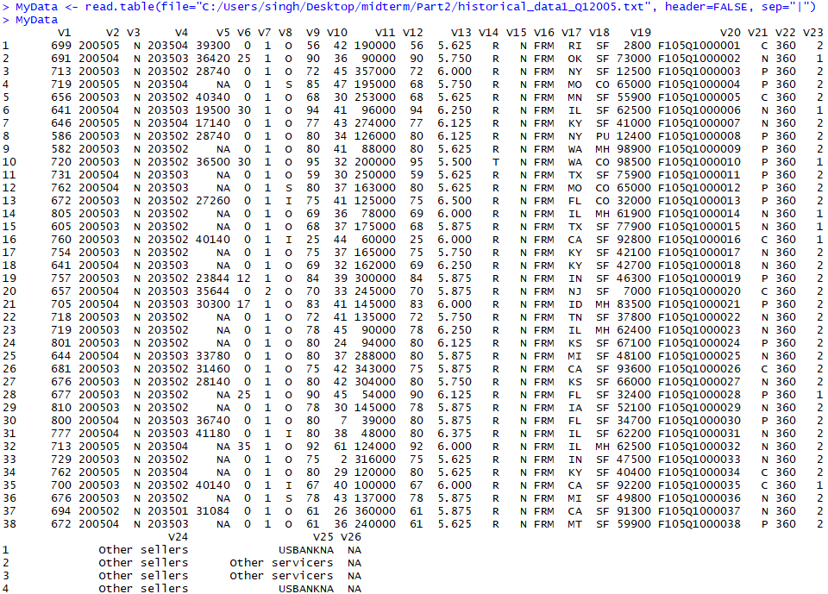

**Defining the data: Name the variables:**

Define Columns

colnames(MyData)<- c("CreditScore", "FirstPaymentDate", "FirstTimeHomebuyerFlag", "MaturityDate",

"MSA", "MIpercentage", "NoOfUnits", "OccupancyStatus", "CLTV", "DTIratio",

"UPB","LTV", "InterestRate", "Channel", "PPMflag", "ProductType", "PropertyState",

"PropertyType", "PostalCode", "LoanSequenceNumber", "LoanPurpose", "LoanTerm",

"NoOfBorrowers", "SellerName", "ServicerName", "Flag")

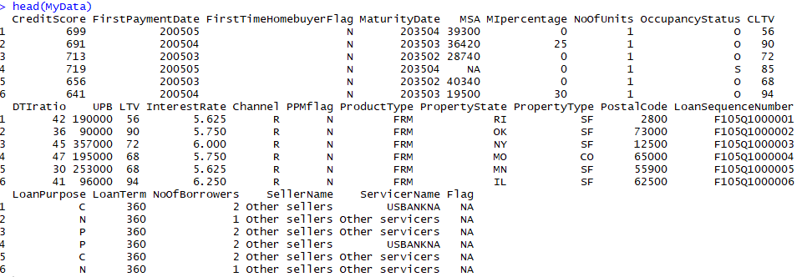

Check the summary of the dataset

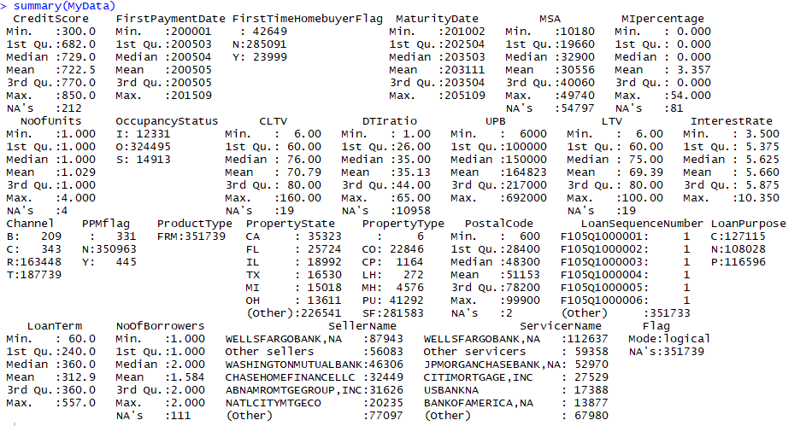

From the Dataset Summary we can see there are number of NAs/ not available data in columns.

Change the data/ column value with meaningful numerical values for prediction and analysis.

**Step 2: Numerical Summaries:**

1. Filling the Missing Data:

Column1: Credit Score 301-850 ; Spaces(3) = unknown, if CS is <301 or >850

So we change it spaces(3) with 301-850 mean

Problem faced in Flag values

f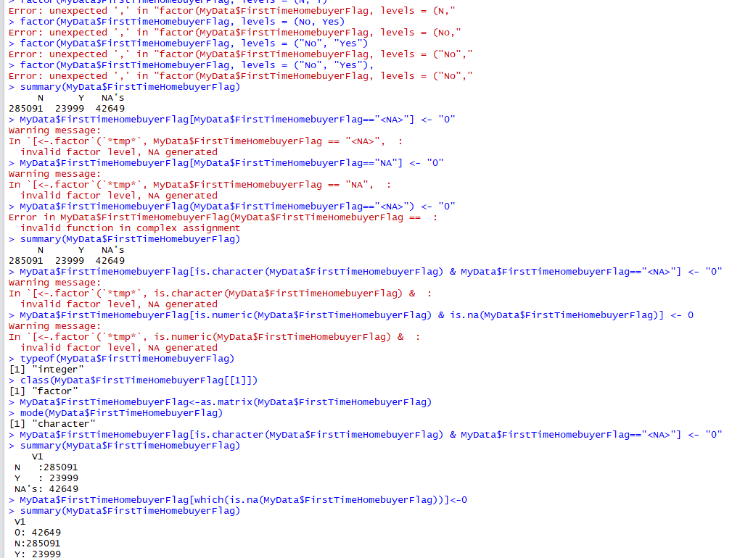

**Preprocess data Remove NA with mean or select the variables**

MyData$CreditScore[which(is.na(MyData$CreditScore))]<-0

MyData$CreditScore[MyData$CreditScore == 0] <- mean(MyData$CreditScore)

summary(MyData$CreditScore)

MyData$FirstPaymentDate[which(is.na(MyData$FirstPaymentDate))]<-0

MyData$MSA[which(is.na(MyData$MSA))]<-0

MyData$MIpercentage[which(is.na(MyData$MIpercentage))]<-0

MyData$NoOfUnits[which(is.na(MyData$NoOfUnits))]<-0

MyData$CLTV[which(is.na(MyData$CLTV))]<-0

MyData$DTIratio[which(is.na(MyData$DTIratio))]<-0

MyData$UPB[which(is.na(MyData$UPB))]<-0

MyData$LTV[which(is.na(MyData$LTV))]<-0

MyData$InterestRate[which(is.na(MyData$InterestRate))]<-0

MyData$LoanTerm[which(is.na(MyData$LoanTerm))]<-0

MyData$NoOfBorrowers[which(is.na(MyData$NoOfBorrowers))]<-0

MyData$SellerName[which(is.na(MyData$SellerName))]<-0

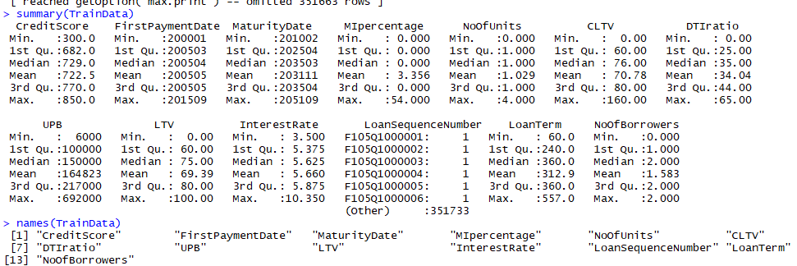

Q. Builds a Regression model for the interest rate using Q12005 data as training data (col 13)

Regression analysis is used to describe the relationship between the independent variables X and how its effecting the dependent Variable Y in the dataset.

A single response variable: Y ; One or more predictor variables: X1, X2,..., Xp

p = 1: Simple Regression

p > 1: Multivariate Regression

**Credit Score** Missing Value is changed with mean as the NULL = value range between 301-850.

Calculate The mean of Interest Rate:

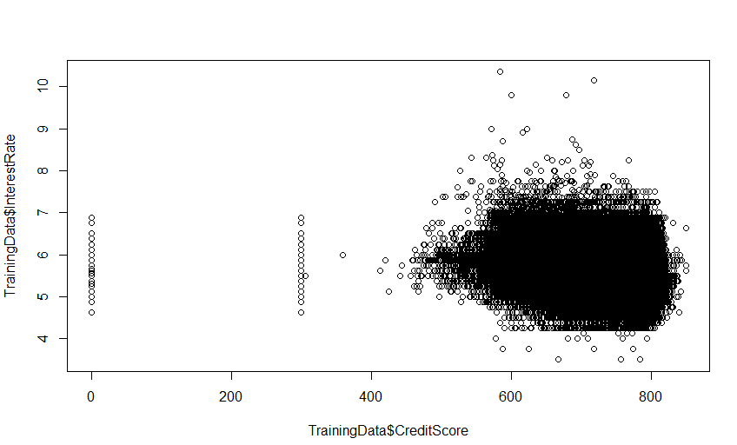

> m=mean(TrainingData$InterestRate)

> abline(h=m)

We calculated the mean of the interest rate and checked the average of Credit Score with Mean Interest Rate

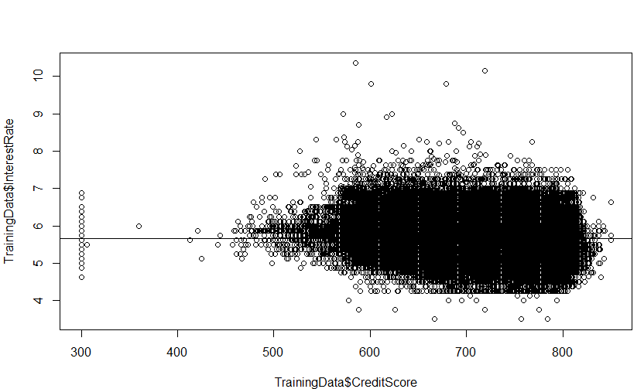

Now we use linear Regression Model (lm) to fit a regression line

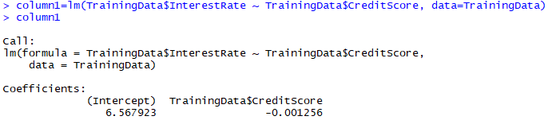

> abline(column1,col="red")

Here intercept is the value of Interest Rate = 6.567923

Whereas the other term is slope: y^/x^= -0.001256 (-ve relation)

**Indicates: More the Credit Score less will be the Interest Rate**

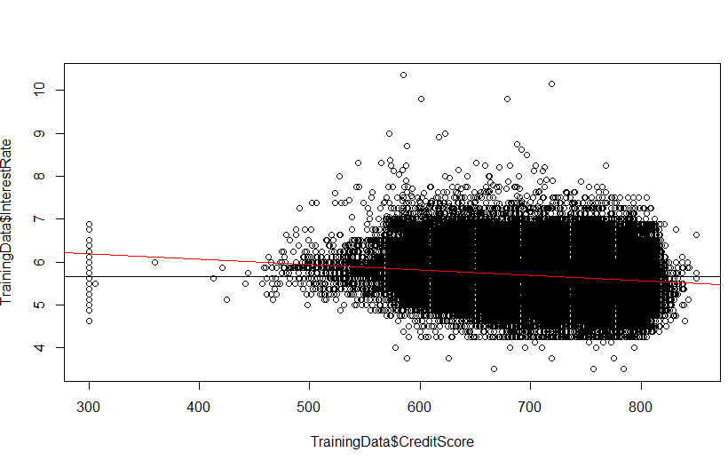

Here the variance decreases with the mean increases, higher the credit Score lower the Interest Rate on Mortgage.

So now we can look at the residuals:

> plot(column1)

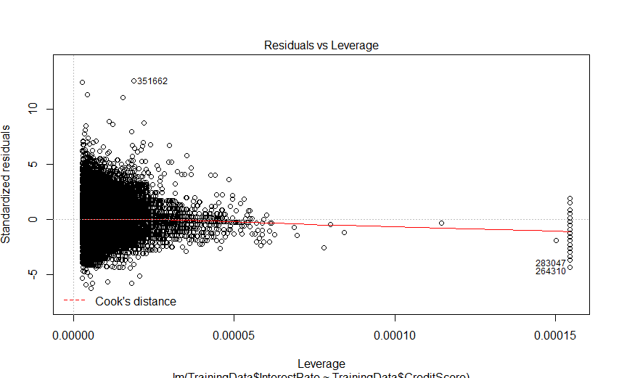 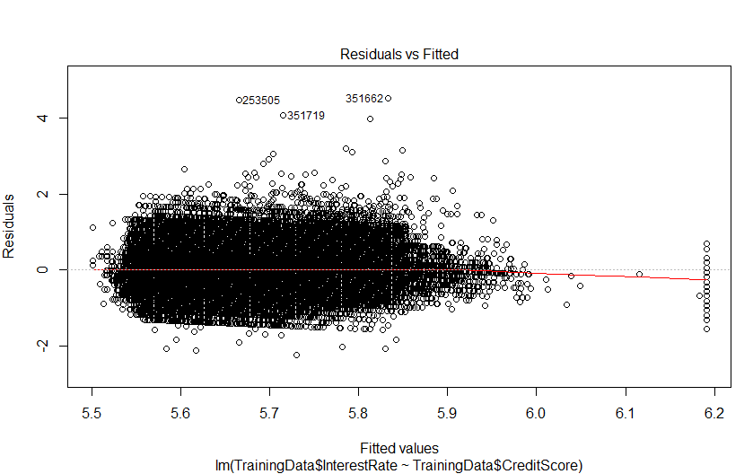

Plot 3: Standard residuals vs theoritical chows: wheather residuals are normaly distributed or not, but here we can see the deviations starting below the line here, which shows distribution is shaped differently than the normal distribution.(not really important for preditions)

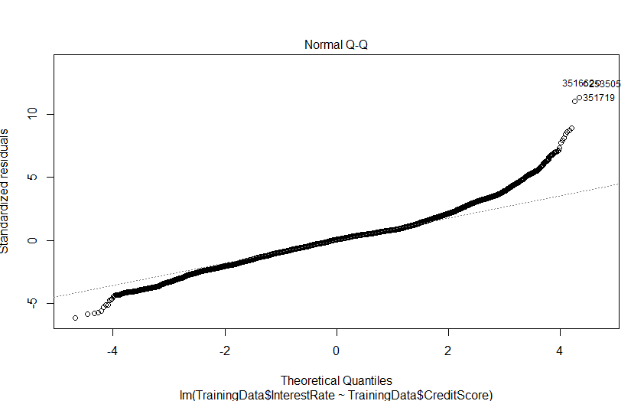 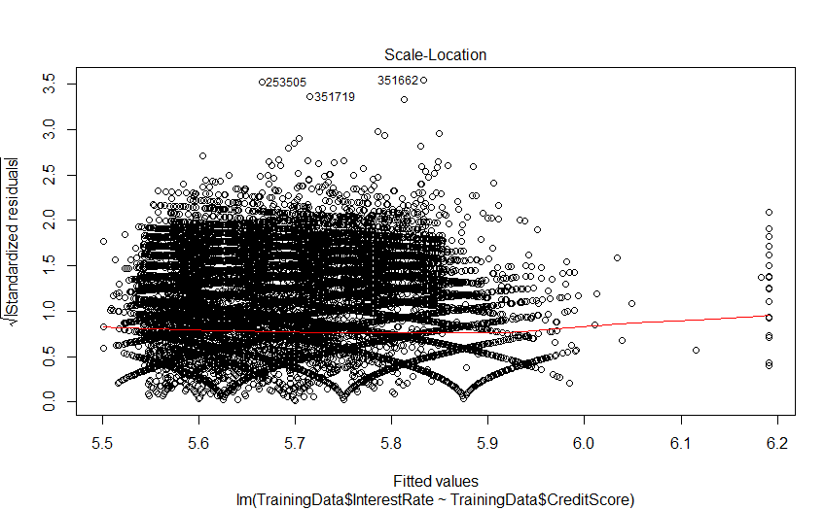

**So we consider the plot Residuals vs Fitted value graph to check if the Credit score is best suited to determine the Interest rate Predictor.**

**Summary :**

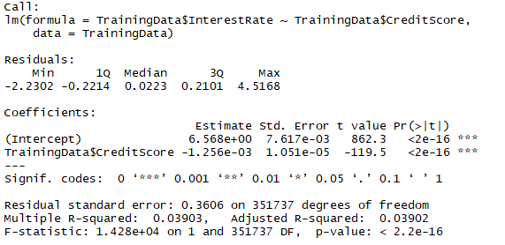

Median of the residuals is : 0.0223, (ideally should be zero)

Mininimum : -2.23.0 & Maximum residual= 4.5168 which is closely distributed along 0 value here.

Most important here are the Coefficients and the standard Error:

Here we have the confident lever the intercept estimated is not 0

Also, the slope(-1.256e-03) is also different from 0.

Also here R-squared: 0.03903,

Adjusted R-squared: 0.03902 (for the degrees of freedom)

Now we use Multiple Regression to check the joint effect of multiple values on Interest Rate

For column 6: Motargage insurance and how it effects the Interest rate:

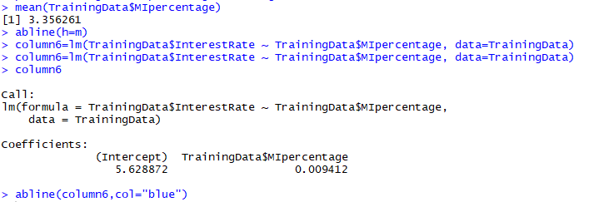

Here the Coefficient is Positive so its effect on RATE of Interest is Positive

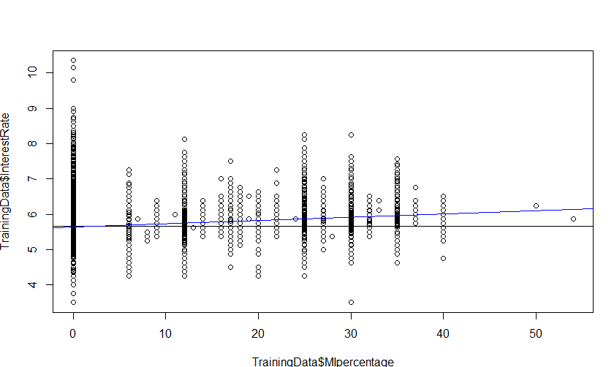

MI% is 0 then there is no influence on the Interest Rate but as it increases it increases the Interest Rate

More the MI% than more is the Interest Rate increases on the property.

Residuals:

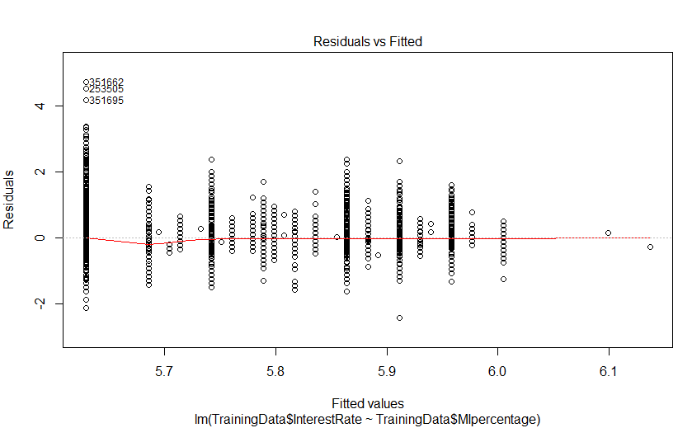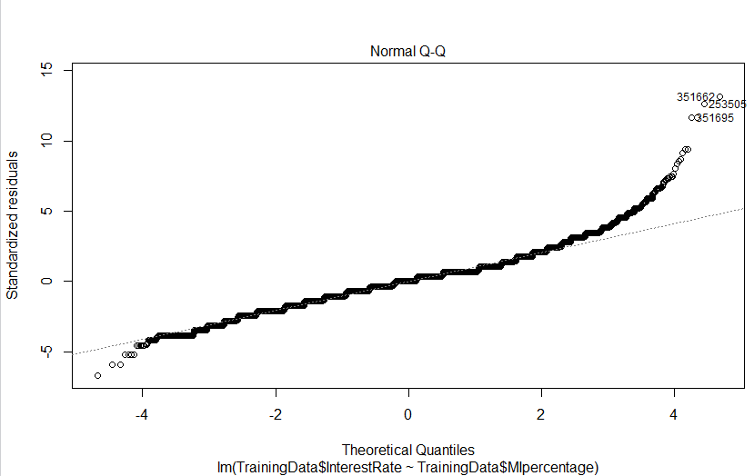

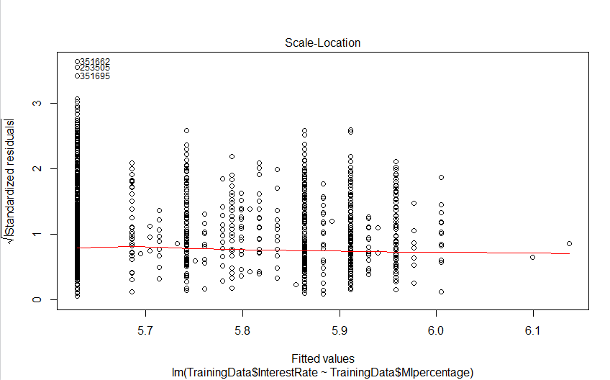 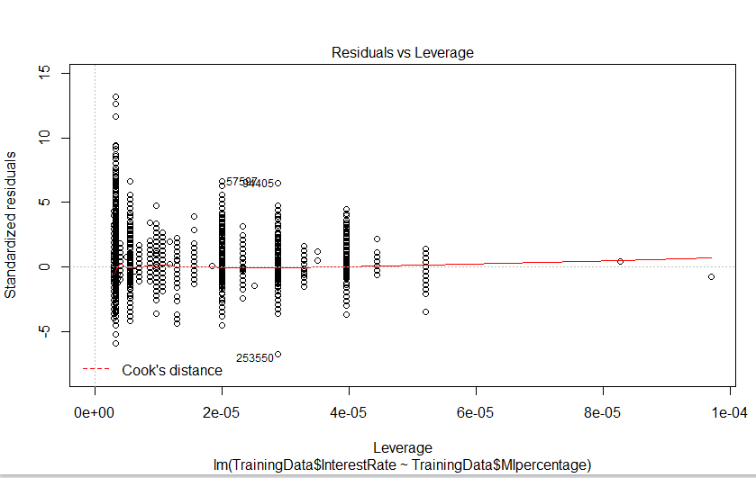

Now if we want to check how MIpercentage changes with the credit score with Interest Rate on the Motergage

coplot(TrainingData$InterestRate~ TrainingData$CreditScore|TrainingData$MIpercentage, panel = panel.smooth)

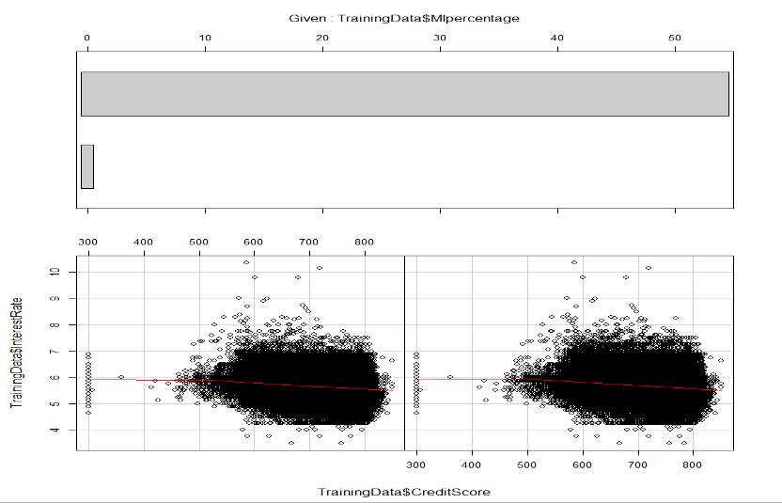

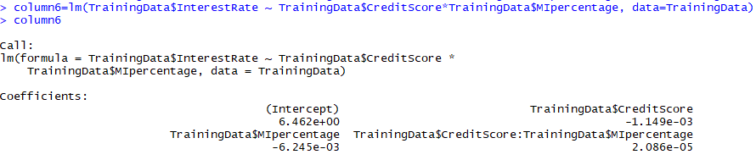

It is linear relationship with the fitted value and Residuals

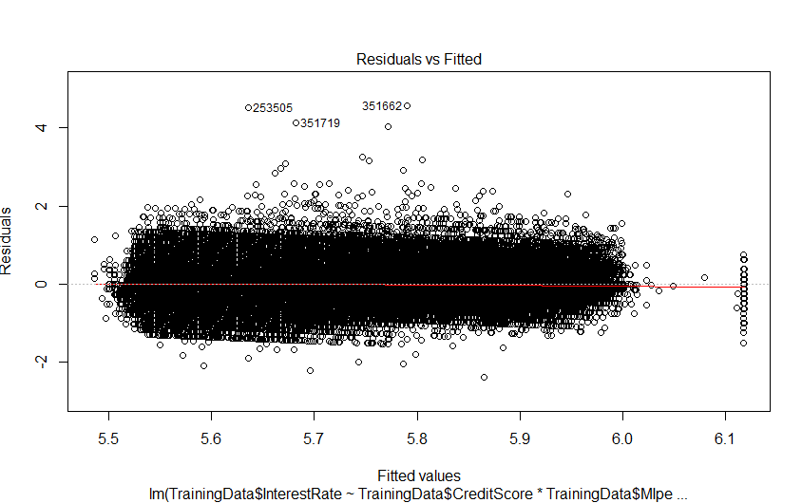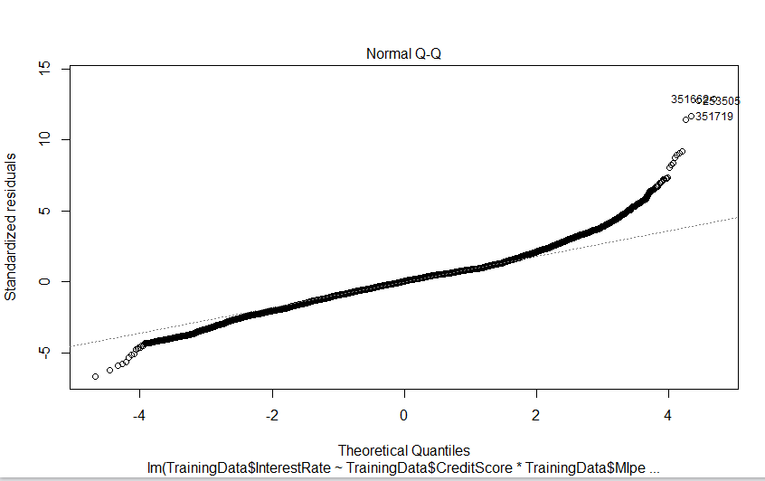

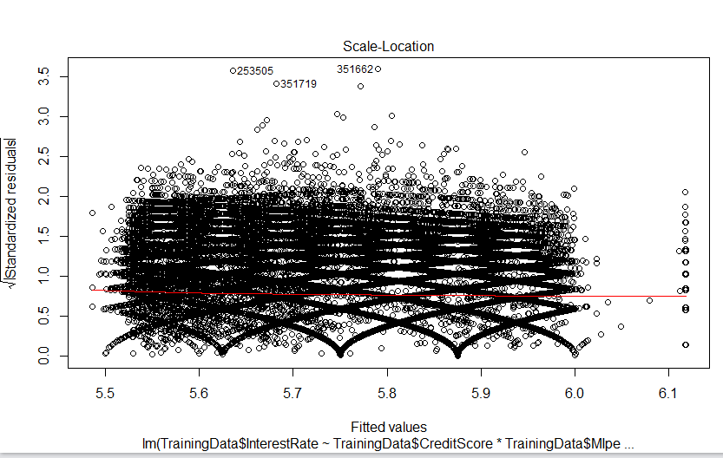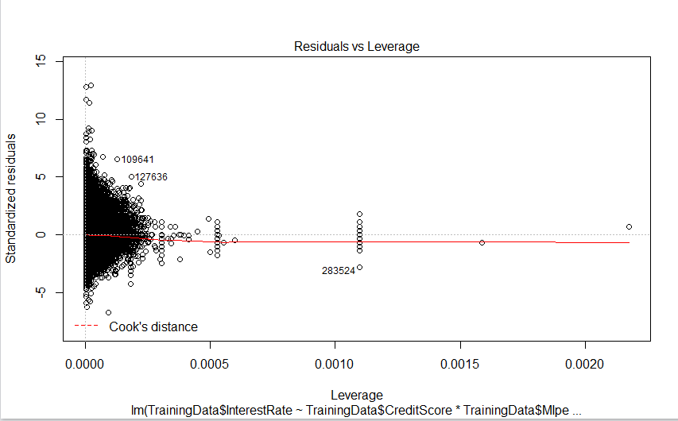

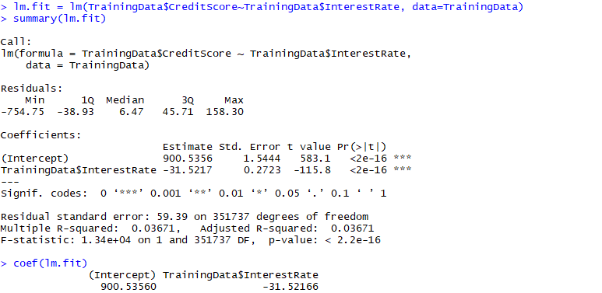

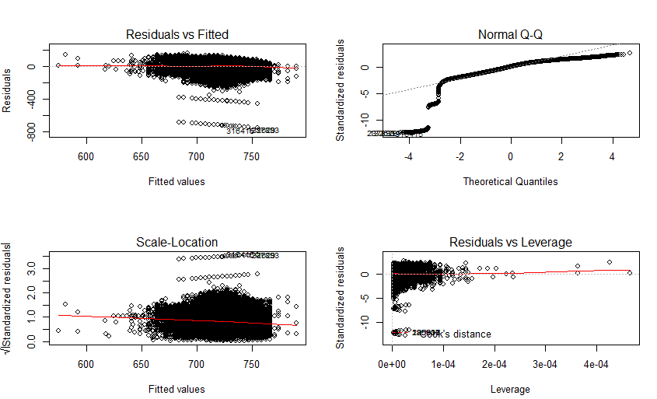

summary(column6)

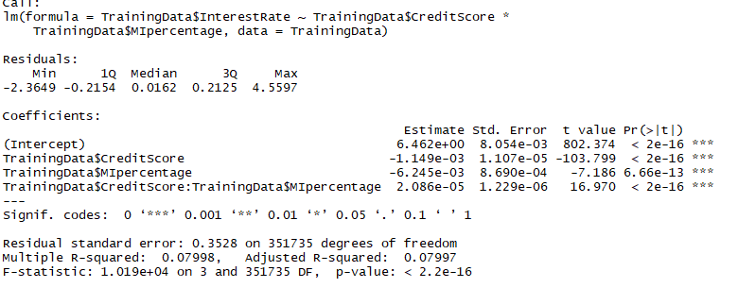

Multiple Regression for all the selected Variables:

> lm.fit=lm(TrainingData$InterestRate~TrainingData$PostalCode+TrainingData$LoanTerm+TrainingData$ServicerName+TrainingData$NoOfBorrowers)

> lm.fit=lm(TrainingData$InterestRate~TrainingData$CreditScore+TrainingData$MaturityDate+TrainingData$MIpercentage + TrainingData$MSA+TrainingData$NoOfUnits+TrainingData$CLTV+TrainingData$DTIratio+TrainingData$UPB+TrainingData$LTV +TrainingData$PostalCode+TrainingData$LoanTerm+TrainingData$ServicerName+TrainingData$NoOfBorrowers)

> summary(lm.fit)

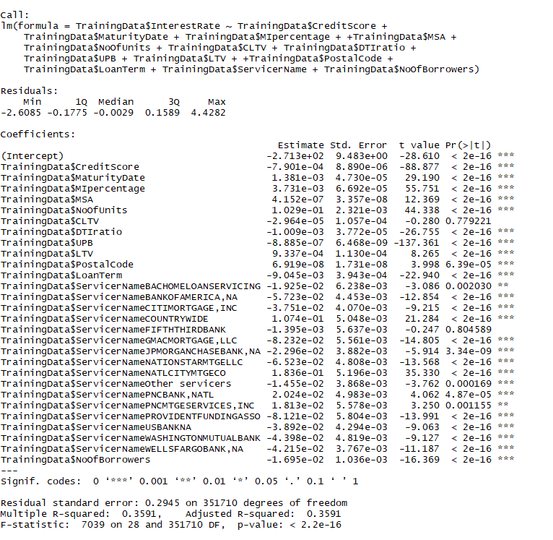

Out of these we do the variable selection using the most significant variable coefficient: and we get due to vector dataset column: state name gives multiple coefficients for Interest Rate.

So, we removed for analysis property State (though it affects the Interest Rate)

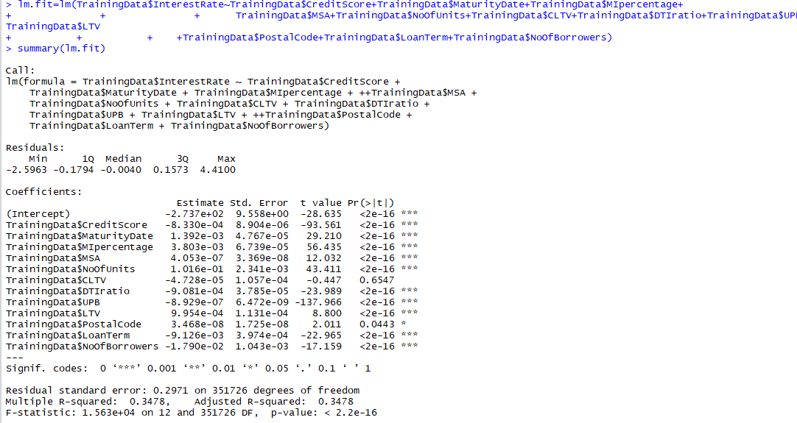

So with variable selection we have 11 columns:

TrainingData$CreditScore -8.330e-04 8.904e-06 -93.561 <2e-16 ***

TrainingData$MaturityDate 1.392e-03 4.767e-05 29.210 <2e-16 ***

TrainingData$MIpercentage 3.803e-03 6.739e-05 56.435 <2e-16 ***

TrainingData$MSA 4.053e-07 3.369e-08 12.032 <2e-16 ***

TrainingData$NoOfUnits 1.016e-01 2.341e-03 43.411 <2e-16 ***

TrainingData$CLTV -4.728e-05 1.057e-04 -0.447 0.6547

TrainingData$DTIratio -9.081e-04 3.785e-05 -23.989 <2e-16 ***

TrainingData$UPB -8.929e-07 6.472e-09 -137.966 <2e-16 ***

TrainingData$LTV 9.954e-04 1.131e-04 8.800 <2e-16 ***

TrainingData$PostalCode 3.468e-08 1.725e-08 2.011 0.0443 *

TrainingData$LoanTerm -9.126e-03 3.974e-04 -22.965 <2e-16 ***

TrainingData$NoOfBorrowers -1.790e-02 1.043e-03 -17.159 <2e-16 ***

TrainingData$ServicerName -5.715e-02 4.449e-03 -12.847 < 2e-16 ***

So We have Train Data Set with the selected Vaiables

Training CLTV, PostalCode has no significant coefficient so we can drop that column and rest of the columns have much significant affect Interst Rate on dataset

Here the values of

R-squared: 0.3478, Adjusted R-squared: 0.3478

Now:

* Run the model on the test set
* Get the measures of predictive accuracy
* 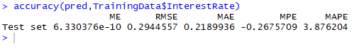

# **Estimated Multiple Regression Equation**

we choose the parameters *α*and *βk* (*k*= 1, 2, ..., *p*) in the [multiple linear regression model](http://www.r-tutor.com/node/100)so as to minimize the sum of squares of the error term *ϵ*, we will have the so called **estimated multiple regression equation**. It allows us to compute **fitted values**of *y*based on a set of values of *xk* (*k*= 1, 2, ..., *p*) .

       ∑
ˆy = a +   bkxk
        k


# **Confidence Interval for Linear Regression**

Exhaustive Search Regression

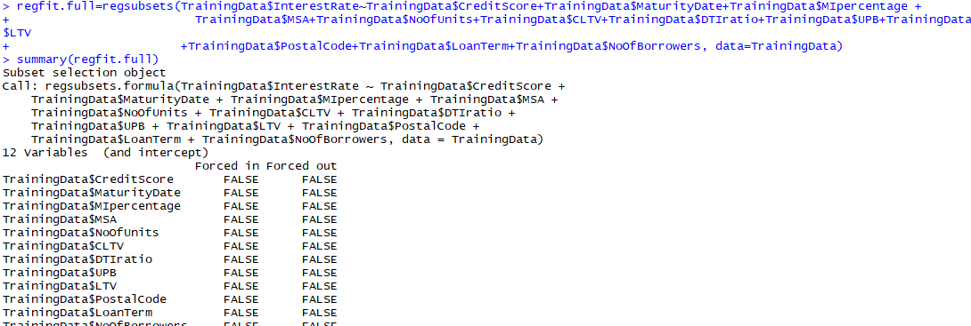

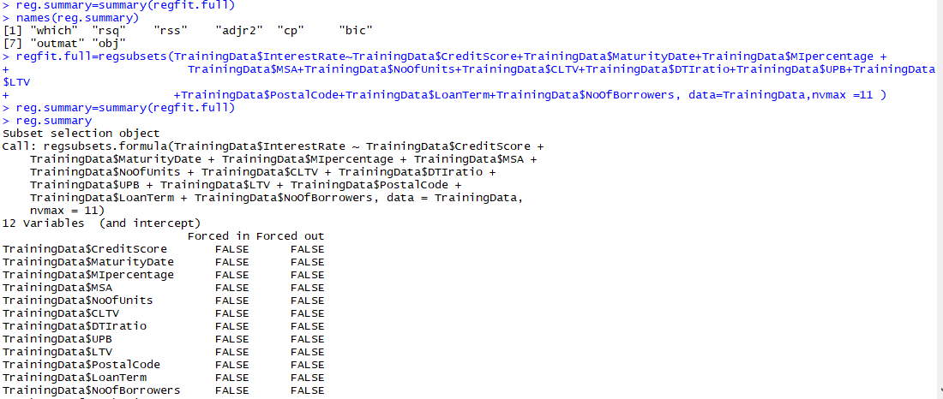

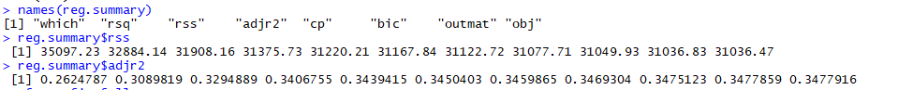

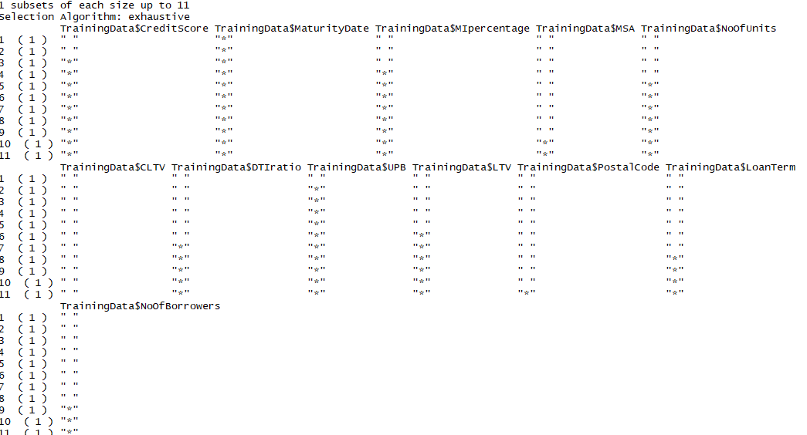

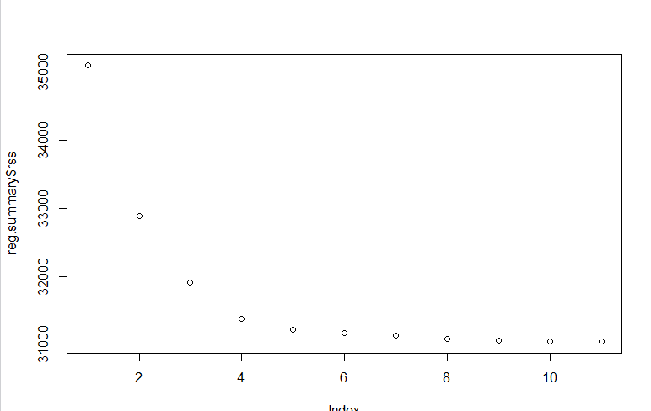 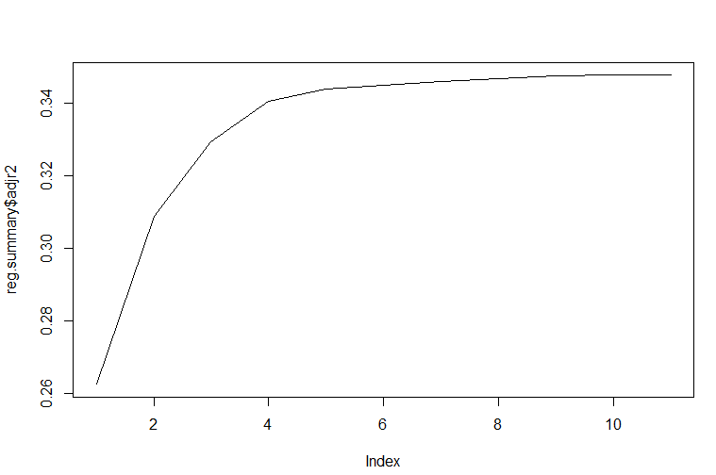

Forward Selection

In the Forward Selection We take all the Train Data Set and Calculate the Squared Error

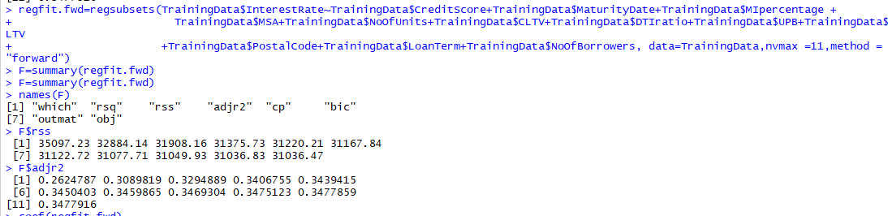

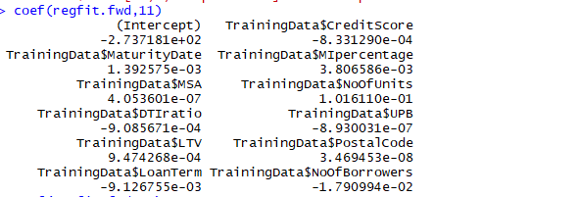

Backward Selection

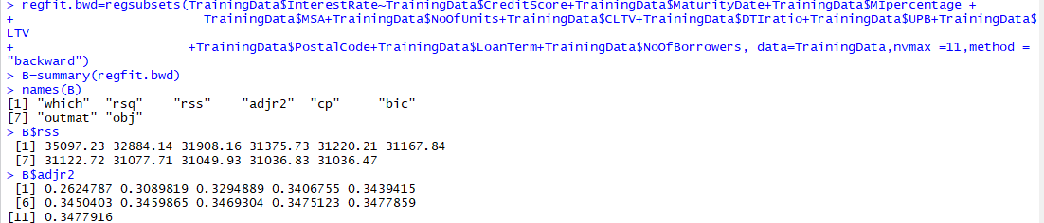

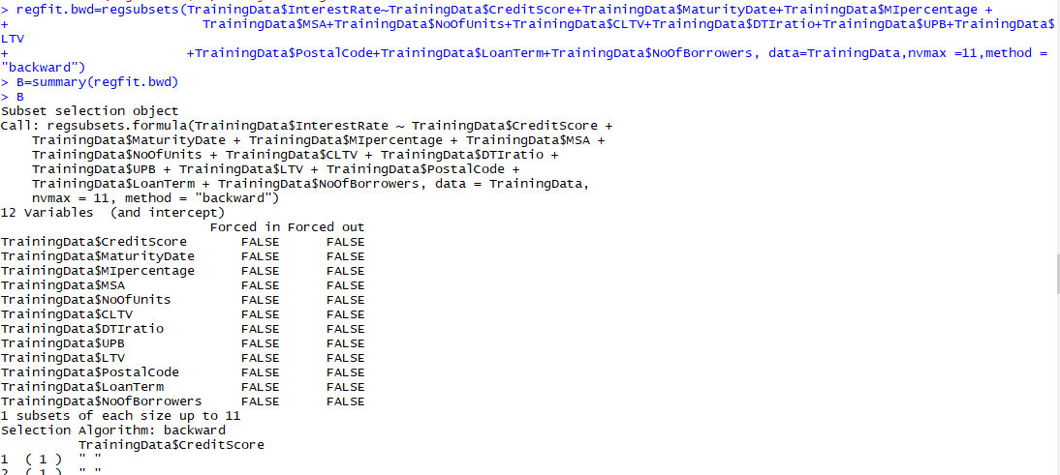

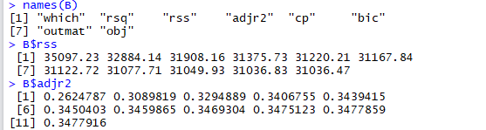

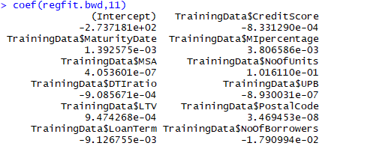

Q. Validates against the Q22005 datasets

Q. Repeat this using Random Forest & Neural Network algorithms.

Q. Choose the best model amongst the 3 types of algorithms.

Part 3:

Classification Loss Fucntion

